16 awesome Russian concept cars that almost made it to production
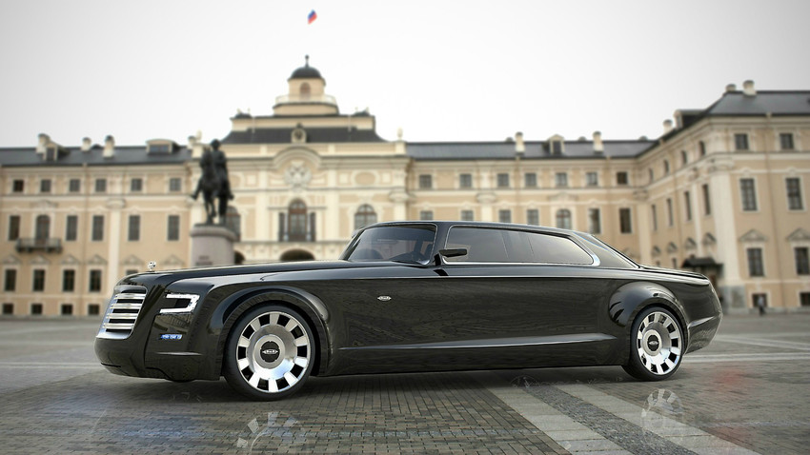
ZIL - the President limo
Maybe Russia can’t boast luxury-class supercars, but for some reason, it's really good at designing the wheels on paper. Let's see how believable these look...
Our country has problems with its automotive industry that both consumers and experts agree on. But it's not due to a lack of imagination. The problem is that most of the time we often can't find a way to go from concept to realization. Whether it’s a communication breakdown between the design department and management, or something else, is anyone’s guess. Today, though, we'd like to give you a glimpse into what Russian cars might have looked like, if only a small percentage of these brilliant modern designs had made it to production. One or two may still get made, if rumors are to be believed.
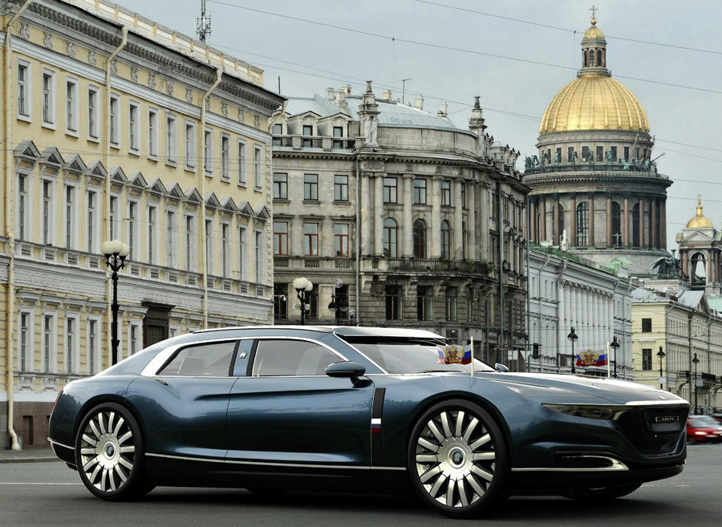
ZIM-12 Akula (Shark)

ZIM-12 Akula (Shark)
One of the retro flagships of the Soviet auto industry, the GAZ ZIM-12 was produced from the late 1950s until 1960, succeeded by the famous Chaika limo. This beautiful concept below was submitted for a design competition recently.

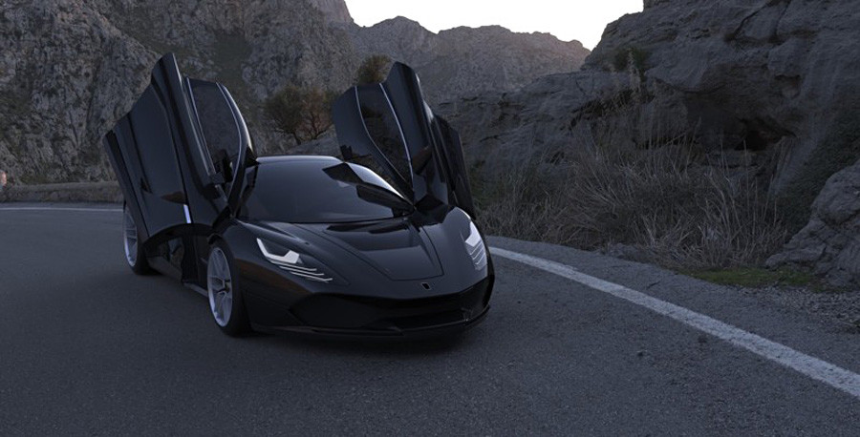
The Volk (Wolf) concept car project from Igor Ermilin, head constructor at Marussia Motors
'Volk' (Wolf), the brainchild of Marussia Motors head designer Igor Ermelin
Sadly, the Marussia Volk was never to be for a number of reasons - chief among them that the company went bust in 2014.

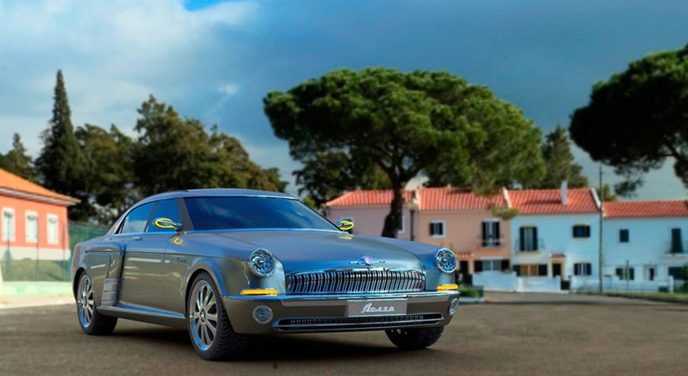
Volga GAZ-21
GAZ-21
This beauty is probably the quintessential Russian car. Produced until 1970, it was also the first GAZ to carry the Volga name, as well as going down in history as the most luxurious car to ever be sold to individual USSR buyers. Behold the thing that could have been...

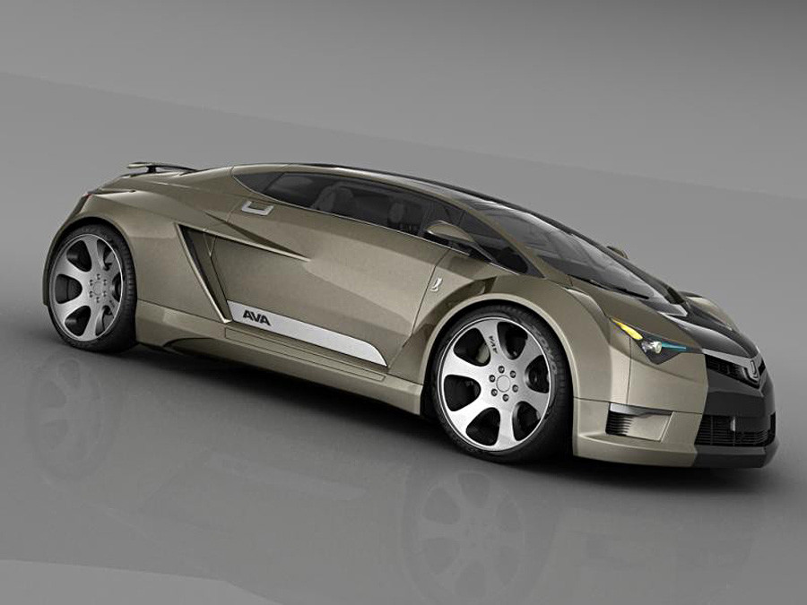
LADA Evolution

LADA Evolution
It is a time-honored tradition in Russia to blast all things domestic. After the breekup of the Soviet Union, the automotive industry particularly took a hit. The criticism could be strange in the case of LADA, given its reputation for reliability back in the day. However, the problem with a lot of these cars was that they just didn't look very sexy. So, when something like the LADA Evolution concept comes out, actually doesn't look half bad, but then doesn't get made, at least one person (the author of this text) is laughing quietly.

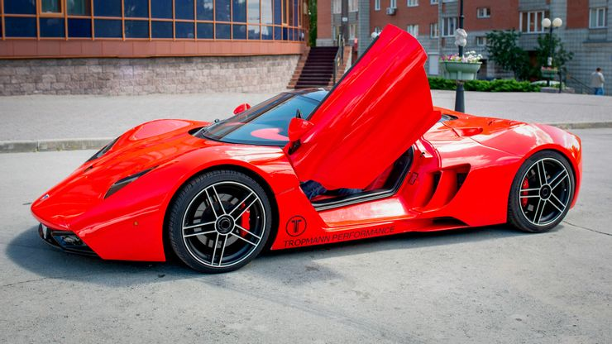

Lada Revolution
Via rbth.com
While the mass-produced Lada vehicles might have a bad reputation, the company has enjoyed something of a resurgence in recent years, and they have even launched their own sports car. The Lada Revolution was unveiled as a concept car at the Frankfurt Motor Show in 2003, though it has yet to go into production.

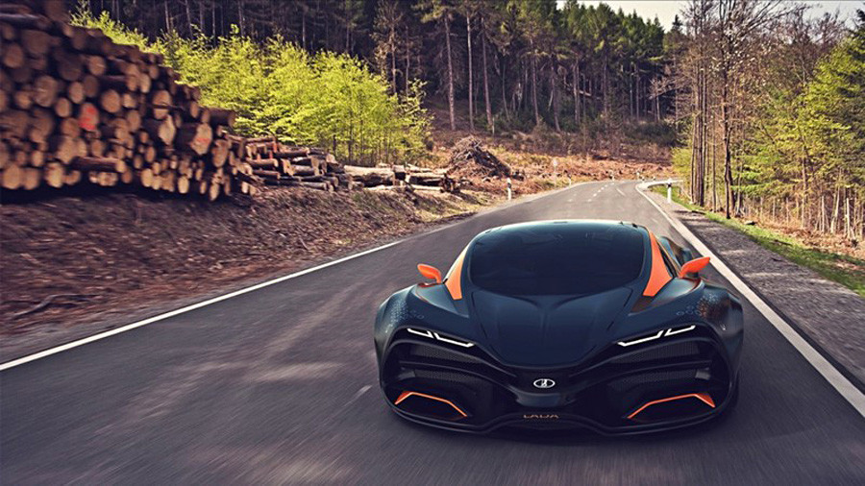
LADA Raven

LADA Raven by Dmitry Lazarev
If you thought the LADA Evolution looked sleek, you haven't seen the Raven. The true definition of a Russian concept supercar: one that doesn't look like it's going to get made... ever... by anyone. The Raven looks unlike any LADA ever imagined before.
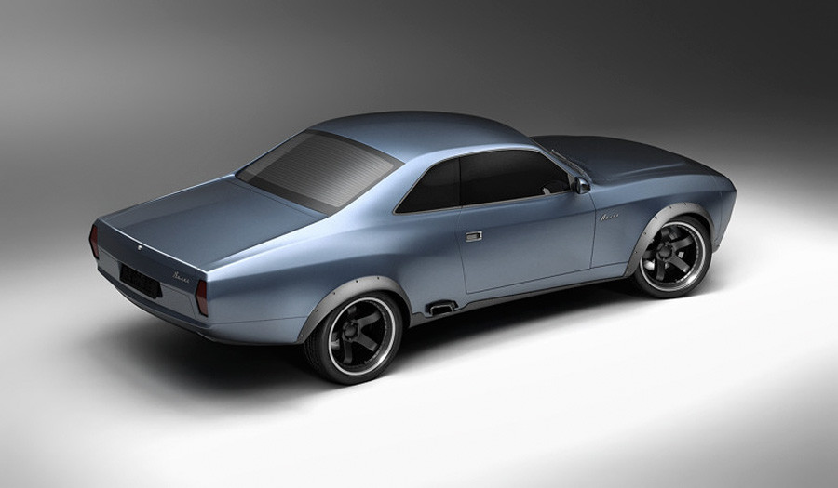
Volga muscle car concept

The new Volga by Stanislav Cheshuin
The author is already imagining himself behind the wheel of this beast, watching the road intensely as he heads somewhere to settle a score. This Volga muscle concept looks like something Clint Eastwood or Charles Bronson might have a use for.

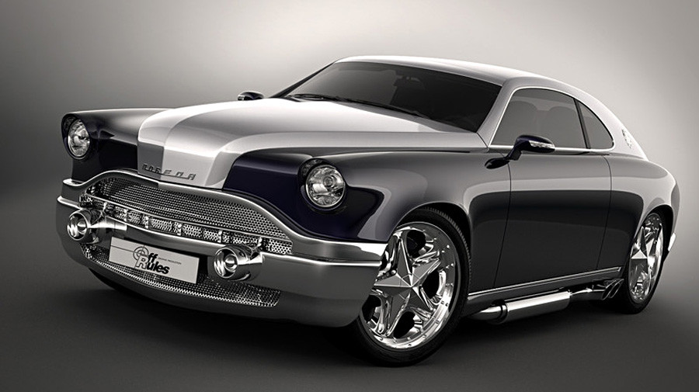
GAZ-M20 Pobeda concept

GAZ-20M Pobeda
Before the legendary GAZ-21, there was the 20. This thing recently got a new lease on life, and one or two actaully even got made (the author saw one once being driven around Moscow, nearly ending up in an accident because of it). There have been numerous concepts like this one over the years.

.
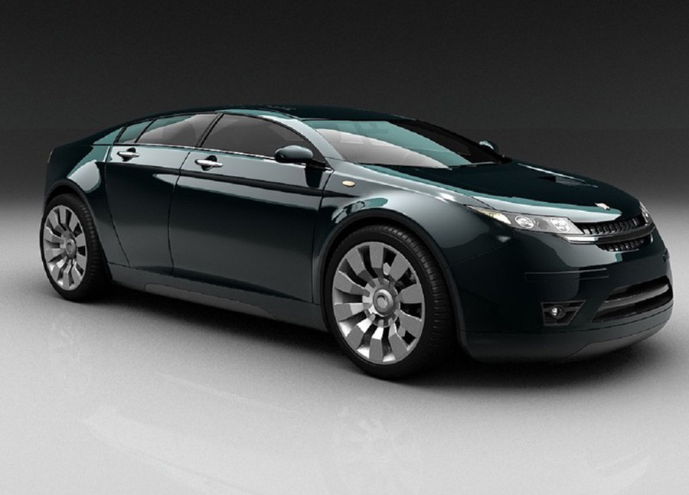
Volga 5000 GL

Volga 5000 GL
Beware, folks, this beauty could still get made. Russia being Russia, there was online chatter since 2011 that the 5000 GL was becoming a reality. There was even word that a prototype was made. Alas, what we see today are most likely Photoshop. But this is still no cause for losing all hope
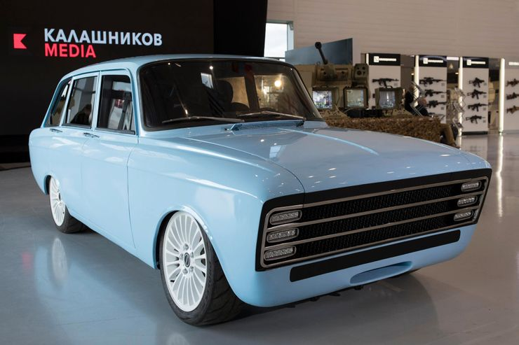

Kalashnikov CV-1
Despite the name, the Kalashnikov CV-1 is not an automatic weapon, but actually an environmentally-friendly electric vehicle with a range of 217 miles. Although built-in 2018, it looks more like it was built in the 1970s – and in fact, it was based on a Russian vehicle from the 70s called the Moskvich 412.
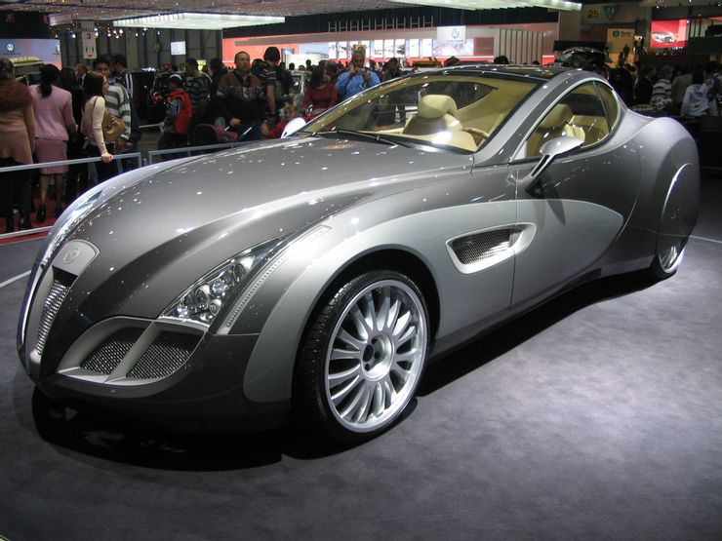

Russo-Balt
Via commons.wikimedia.org
During the pre-Soviet years, Russo-Balt was one of the country’s most successful companies, producing military vehicles and aircraft as well as cars. One of their first cars was the C24-55 which was built in 1912 for that year’s Monte Carlo rally. The company has recently made a comeback, with the Russo Baltique Impression.
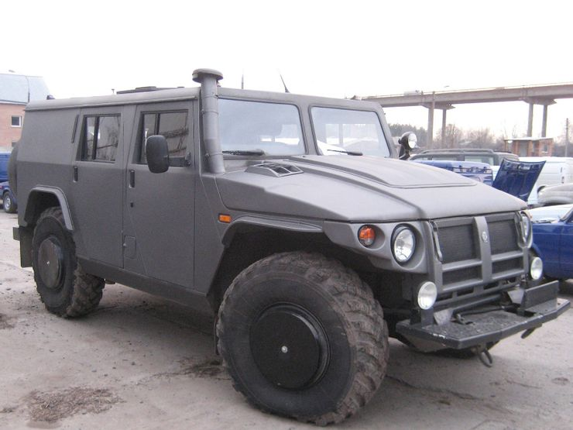

GAZ Tigr
Via nationstates.com
The Marussia F2 may be a serious SUV but it pales in comparison with the GAZ Tigr. Developed for use by the military, it is available for civilians to buy – if they have the money. Bearing more than a passing resemblance to the Hummer, production on the Tigr started in 2006 and civilian models will set you back at least $110,000.
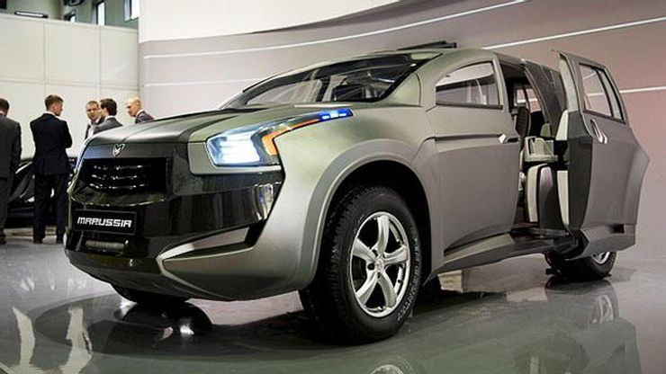

Marussia F2
Via motor1.com
Russian company Marussia didn’t just build sophisticated supercars; they also launched their full-size SUV, the Marussia F2, in 2010 as a concept car. The bulky SUV has some luxurious interior features, and novel sliding electric doors, which have been borrowed from the more familiar Bertone or Lamborghini Genesis from the 1980s.
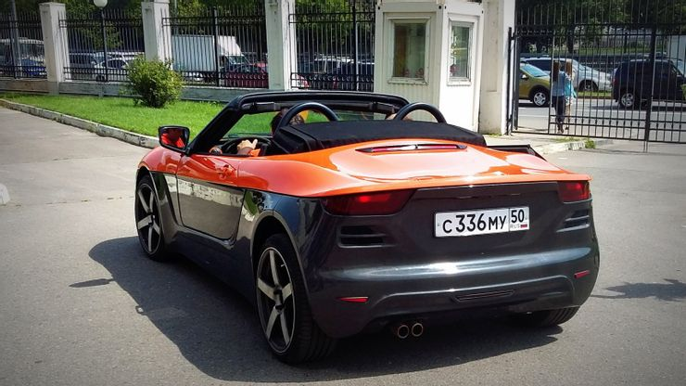

Crimea
Based on a Porsche Boxster, and built out of Lada parts, the Crimea (or Krym as it is known in Russia) is a sports car that isn’t really very sporty. While it may look the part, with an eye-catching black and orange design, it takes a slow and lingering 8.5 seconds to accelerate from 0 to 60 mph.
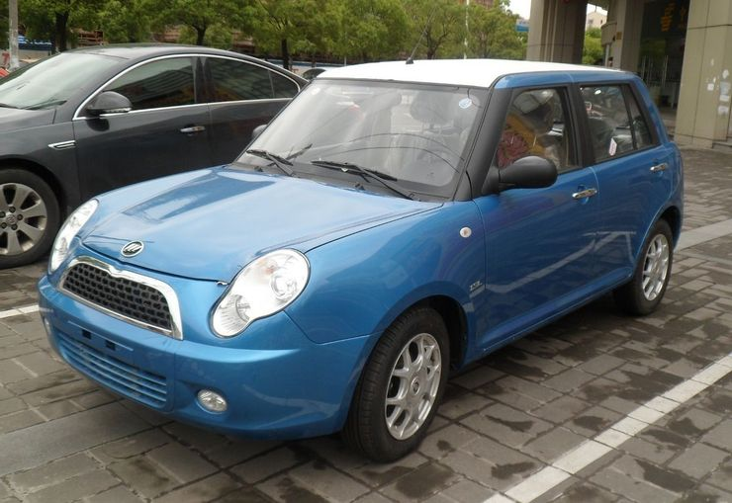

Lifan 320

No, it's not a MINI Cooper: The Lifan 320, also known as the Lifan Smily, is a Russian subcompact made to mimic the ever-popular MINI Cooper. Much to the rest of the world's dismay, Lifan has been producing the 320 since 2009. The car comes equipped with a tiny 1.3L 4-cylinder engine and can reach a blistering top speed of 96 miles per hour.

Russia to develop civilian airliner based on nuclear bomber
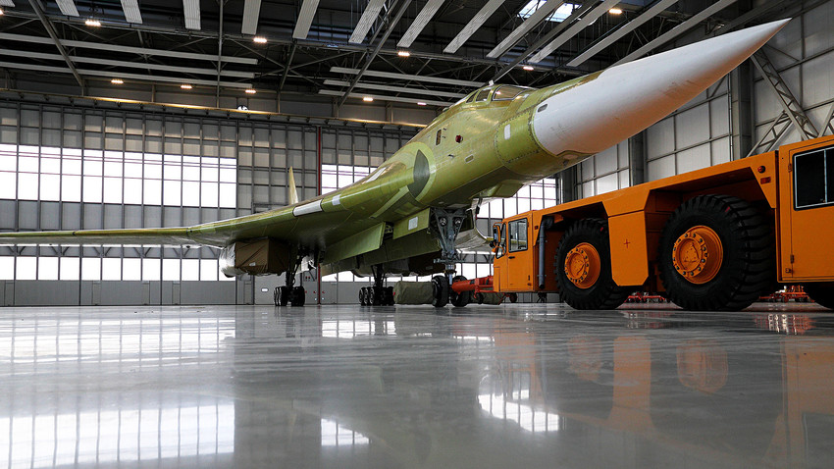
A prototype model of the Tu-160M2 aircraft is rolled out at the Gorbunov Kazan Aviation Plant, a subsidiary of PAO Tupolev.
Following the maiden flight of the upgraded Tu-160 strategic bomber, Russian President Vladimir Putin suggested that a supersonic airliner should be developed using the same technology.
In mid-January Russia's weapons manufacturers showed-off the upgraded Tu-160 strategic bomber to the country's president, Vladimir Putin. But the headline of the day wasn’t the maiden flight of the “White Swan” - as pilots call the aircraft - but Putin’s wish to develop a supersonic civilian plane based on Tu-160 tech. The head of the United Aircraft Corporation, Yuri Slyusar, says his company has already created a blueprint for such an aircraft and that aspects of the new bomber could be incorporated into the plans. The idea has left journalists asking: “What would the plane look like?” So far, the plans remain secret.
‘White Swan’
The Tu-160 is the most powerful supersonic bomber and “missile platform” in the history of Russian military aviation. According to Putin, Russia will make ten Tu-160s costing about $267 million each in the near future. Military experts say the planes will be used not only in a deterrent role but also for the Defense Ministry's other day-to-day operations. Tu-160 can also carry up to 150 passengers but the public will have to wait at least a couple of years before the plane’s civilian prototype.

Could Russia's Frigate Ecojet take on Airbus and Boeing?
The Frigate Ecojet – Moscow-based aviation company Rosavia is taking on giants Airbus and Boeing with its new Frigate Ecojet aircraft concept. Market gap – Rosavia hopes to plug a gap in the market by combining the capacity of a wide-body aircraft with the economics and range of a narrow-bodied one.
Two aviation giants dominate the field: U.S.-based Boeing and European consortium Airbus.
So can a Russian upstart succeed in its goal of redefining the market with a new aircraft concept whose unique characteristics place it in a category of its own? The new manufacturer is Moscow-based private company is Rosavia. Its concept is the inelegantly named Frigate Ecojet.
Wide body vs. narrow body
Airliners can be roughly divided into two groups. There are wide-body aircraft, like the Boeing 777 and 787 or Airbus A330 and A350 families, designed to carry 250 or more passengers on long-haul flights. Then there are narrow-body aircraft: smaller single-aisle craft usually seating fewer than 200 passengers and serving short- and medium-haul routes. The Boeing 737 and Airbus 320 families are the most common in this category. But what if an airline needs to transport a large number of passengers over relatively short distances?
One option is to use a wide-body airline -- much heavier than required for short distances.
The other is to use narrow-body aircrafts, flying at greater frequency, and to give up some of the economies of scale that high-density routes can afford. Neither is an ideal solution.
Russian tradition
The Frigate Ecojet aims to bridge this market gap by combining the capacity of a wide-body aircraft with the economics and range of a narrow-bodied one. It's been designed to fly between 276 and 358 passengers over distances of 3,000 to 4,000 nautical miles, depending on the model.
Although currently a private company, Rosavia follows the tradition of Russia's aircraft design bureaus. Some of its senior technical personnel were involved in the roll-out of airliners such as the medium-range Tupolev Tu-204 and the Tu-214. If it’s positioning as a medium-haul wide-body airliner sets the Frigate Ecojet apart in the market, its most eye-catching feature is without doubt its curved fuselage.
Rosavia's engineers say its elliptic shape is a particularly efficient solution for seating more than 350 passengers in a three-aisle configuration, while keeping weight and dimensions below those of wide-body aircraft of similar capacity.The main challenge the Frigate Ecojet faces isn't technical, though, but commercial. Is there enough demand for an aircraft with these characteristics?
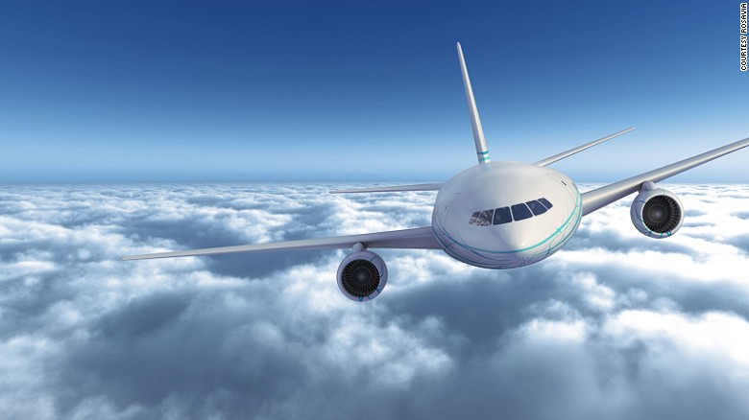

There's no doubt that the Frigate Ecojet is a bold and ambitious undertaking, even more so when considering it's being led by an independent private company. However, it's precisely this slice of the market that saw the beginning of one of the most successful growth stories in the history of commercial aviation.Although the market and political environment is vastly different, it's easy to forget -- four decades after the first Airbus A300 took to the skies -- that the once mighty and diversified Airbus Group also started with a medium-haul wide-body airliner designed for the same tasks that the Frigate Ecojet now hopes to fulfill.

- Which car would be the best for development? Choose 2 or 3 cars for further investment. Research them a bit more. Compare and Contrast them. Explain your reasons for choosing them.
- Which plane idea is better? Argue the pros and cons of both sides. What are the advantages and disadvantages of each new plane? Would you invest in this idea? Why or why not?
- Could these ideas (supersonic and domestic regional planes) be used to open up the economy of Siberia and other remote parts of Russia? Do you think more airports should be built in the areas that have nothing in order to stimulate the economy? Why or why not?
- Should Russia develop its own planes to compete with Boing and Airbus? Why or why not? Is there a better way to compete with these two Giants?
- Research LADA. DESCRIBE THE COMPANY Does this company have the potential to finally become a world competitor in the automobile market?
What can be done to make LADA popular around the world. ( compare with Hyundai or any others )

